Interviewing of Keith Rand

For my Interview a Professional Project, I interviewed Mr. Keith Rand. Mr. Rand currently holds many titles, Texas Ranch Sales Real Estate Agent, Superior Livestock Representative, former Sales and Marketing Representative at Vaquero Energy Services as well as being a part of the TV show Pigman the Series. Keith attended SFA University but quickly figured out he was ready for work instead of school. Mr. Keith Rand is my father, I conducted the interview in person, and I look up to him often in many different aspects, career goals and as an individual.

To begin our interview, I asked Keith to tell me about all of the things he is a part of and how he got started. With diverse circumstances in the ranching and cattle industry, Keith has accumulated valuable experience in various sides of the field. He began by selling farming equipment with Dixon Industries and Great Plains Manufacturing before on a two-year term as a Farm Bureau insurance sales agent. Keith’s go-getter spirit led him to establish Vaquero Energy Services, a thriving oilfield service company that employed nearly 300 individuals until the industry crash in 2018. Additionally, in 2008, he co-founded the highly acclaimed television show “Pigman the Series” on the Sportsman channel. The show has since become the most-watched outdoor TV program, possessing a dedicated following. While Keith’s involvement in the series is now very little, his input has been significant. Additionally, Keith operates a cow/calf operation in Groesbeck Texas alongside his wife and kids. He also manages Nutricion de la Frontera, also know as Border Nutrition, focusing on cattle and deer feed and animal nutrition in both Texas and Mexico. As a Superior Livestock representative, Keith affectively markets cattle through video and online sales across the world. In addition to his journeys, he owns T4R Services, a small oilfield service company operating in south and west Texas. In 2008, through his love and passion for hunting, Keith established Last Frontier Outfitters, offering exceptional trophy Whitetail, hogs, and exotic hunts throughout South Texas and the brush country of Mexico.

Keith explained that advertising is they key to promoting. It is essential to selling land, cattle, equipment, and deer hunts. You could have the best-looking cattle, biggest nicest ranch or house in the area, or any other product for that matter, but without marketing and advertising there would be no way for anyone to explore what you have and you would be at a standstill with any interests and sales. One example of the importance of advertising he has personally experienced was when he was working for Texas Ranch Sales and decided to switch to another real estate company. He immediately noticed there was difference in inquiries about his listings. He says that Texas Ranch Sales was extremely adamant about their marketing, whether it be magazines, social media, or yard signs, and it didn’t take long for him to decide it was best for him to switch back, solely for the reason he was getting no business with the new company from the cause of poor advertising.

Three tips that Keith would give to someone who is getting started in marketing and advertising are to first, concentrate on building a brand and following. This is extremely important when getting started because you want people to notice you. You need to find something to hook people in so they will be interested in your content. Make sure to have valid content that will draw attention, something that is attractive, be informational and educational, and merit. Last but certainly not least, be responsive. You need to learn to be able to interact with people that inquire and like or follow your social media. Be able to communicate and be involved with them, as it will only draw more people in if you are a good communicator.

We discussed how social media is such a big deal in our society today. I asked him to put into words how he would describe the change of how it was when he started to how it is today. Keith said social media went from zero to 100 very quickly. As he was growing up and even after having children, there was no social media. He explained when it first came about, him nor his wife wanted anything to do with it, until they quickly realized that it was very important especially being in the field he is in. He says, social media has changed the world and it is awesome, I am able to do so much on my phone, even if it’s while I’m sitting in my chair with a cocktail. Social media has brought to me more connections than I think of. You can also become connected with so many people, businesses and organizations. It is an excellent thing to be a part of in the business world. Lastly, he states that he wishes he would have become more involved earlier and known more about digital marketing than he did going in, although he has come very far in his networking and it has helped him very much throughout all of his endeavors.

I was honored to interview my dad to talk about what he does on a daily basis. He has taught me many things in life but I have enjoyed hearing the ins and outs and his answers of the things I asked him today. He is an extremely hard worker and I aspire to be able to connect with diverse individuals like him in my career. I will be sure to take the tips he provided for myself as I start in my marketing and advertising career.

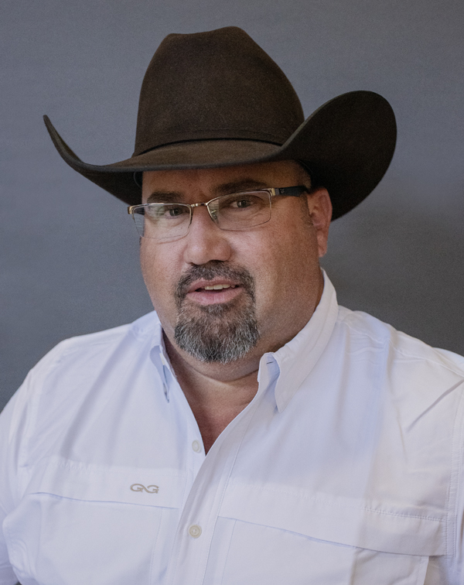

*Picture is a professional headshot that he provided for me.*

* Linked In Profile:

**Keith Rand**

**Texas Ranch Sales, LLC**

**Contact** (Linked In)

<https://www.linkedin.com/in/keith-rand-3aa10530>

903-391-8802

List of questions asked in interview:

1. Tell me about the things you are involved in and a part of and how you got started.

2. How important is the advertising and marketing industry in your career?

3. What are three tips you would give someone starting out in marketing and advertising?

4. How has social media changed since you entered the field?

5. What do you wish you would have done differently or known more about when getting started?